Intro to Arduino IDE and Hello World

Arduino IDE
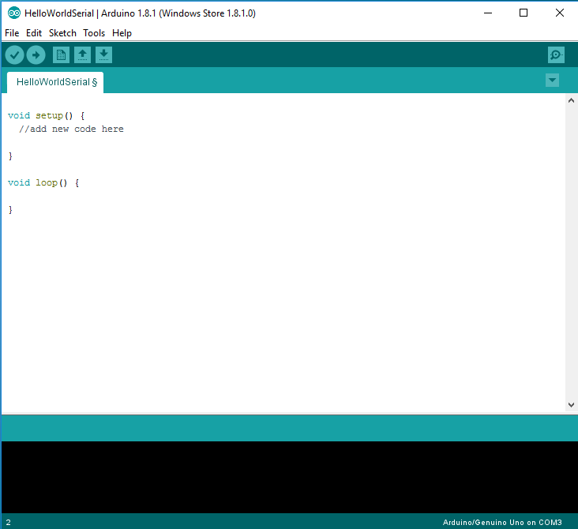
The Arduino Integrated Development Environment (IDE) is a suite of tools used to write code, load it to the Arduino, and debug it. An Arduino program is referred to as a 'sketch.'

Make sure your Arduino is connected to the computer using the USB cable.
This sketch, as currently written, doesn't actually do anything; but its still technically a valid program. We can walk through the process of loading it onto the Arduino.

Start by pressing the verify button. This compiles the code; which means it takes the code you’ve written, and turns it into a binary file the computer can execute. During this step, we will discover if our code contains any errors; if errors exist, the compilation will fail and the IDE will give you feedback about what went wrong.

Next, use the upload button to send this sketch to the Arduino. You should see the process complete, and the IDE will report that the upload is done.
Note: pressing upload automatically verifies your code before uploading; so when you’re ready to upload you won’t actually need to press verify.
Toubleshooting: If the IDE complained about uploading, go to the tools menu and make sure you have the right COM port selected, it should tell you which is the Arduino.
Hello World
It's traditional for programmers encountering a new language to write a very simple program, called a “hello world” program. In this program they confirm that their system is correctly configured to build and run their code. In traditional programming languages this prints the phrase 'Hello World' to the screen. Since our code runs on an Arduino, which does not have a screen, our Hello World program will instead print the phrase "Hello World" to the serial port, and the computer will then print it to the screen.
We will now modify the provided code to create a Hello World program:
- Locate the comment that shows us where in the sketch to start adding new code.
- Start by adding the following line exactly as written:
Serial.begin(9600);
This line tells the Arduino to start a serial connection with the computer, at a speed of 9600 baud.

- Go down to the next line and write:
while(!Serial) {}
We will talk more about control structures and loops later. For now, just know that this line of code waits for the serial connection to be established before proceeding.

- Finally, add the following line to complete the program
Serial.println("Hello World");

This line writes the text “Hello World” to the serial line. If everything goes well, we should see it appear on the serial monitor when we run this program.

- Save your progress, then press the upload button.
- When the upload completes, open the serial monitor.
- Make sure that the baud rate for the monitor matches the baud rate we defined in our program (9600).

You should see the text 'Hello World' appear on screen. Congratulations, you have finished your first Arduino program!

